create a html document for registering employee, below are the screens for how the page should be rendered in browser

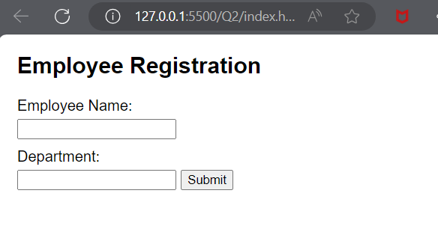

1. Name should not be empty, show validation fail message as invalid name.

1. Department should not be empty, show validation fail message as invalid department.

1. when form is submitted, The feedback is given below, please check the third screen.

